# Project: Analyzing a Market Test

## Step 1: Plan Your Analysis

**1.What is the performance metric you’ll use to evaluate the results of your test?**

I have chosen the sum of gross margin as the performance metrics to evaluate whether to introduce gourmet sandwiches and limited wine offerings to spur sales growth in Round Roasters

**2. What is the test period?**

The test period is from 29th April 2016 to 21st July 2016. Additionally, a time-period of 12 weeks is used as the test period.

**3. At what level (day, week, month, etc.) should the data be aggregated?**

The data has been aggregated at the weekly level.

## Step 2: Clean Up Your Data

**The given datasets RoundRoasterTransaction** and **Round-Roaster-Store** datasets are first combined. In this experiment, 76 weeks data (6-Feb-15 to 21-Jul-16) is used. As A/B test requires 52 weeks of data in addition to a minimum of 12 weeks needed to calculate seasonality and for the period of testing each.  
12 weeks is used as the test period lasted for 12 weeks.

I have also introduced the following new columns of data. They are week, *week_start* and *week_*end. These new columns are added to calculate the weekly traffic and sales for each store. **Treatment_Store** dataset is then used to create a list of control and treatment stores for this project.

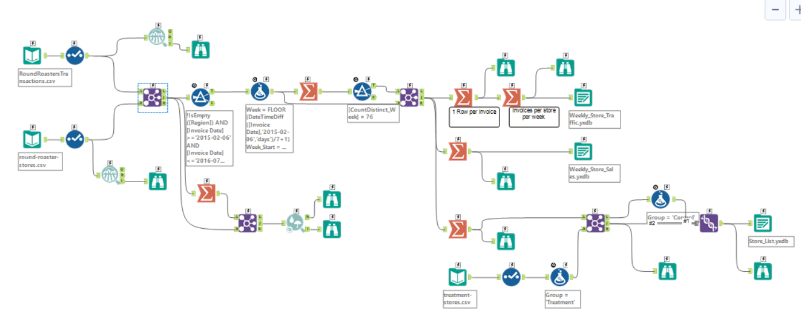

Figure 1: Alteryx Workflow to clean up data

## Step 3: Match Treatment and Control Units

**1. What control variables should be considered? Note: Only consider variables in the RoundRoastersStore file.**

AvgMonthSales should be considered as constant variables while Square Feet is not required for analysis.

**2. What is the correlation between your each potential control variable and your performance metric?**

From the Pearson Correlation Analysis, AvgMonthSales has a high correlation of ~ 0.99 with the performance metric, i.e. Sum of Gross Margin. On the other hand, Square Feet has a poor correlation of -0.07.

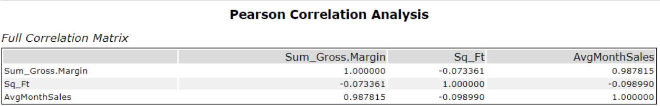

Figure 2: Pearson Correlation Analysis

**3. What control variables will you use to match treatment and control stores?**

AvgMonthSales data will be used together with Trend and Seasonality when matching treatment and control stores.

**4. Please fill out the table below with your treatment and control stores pairs:**

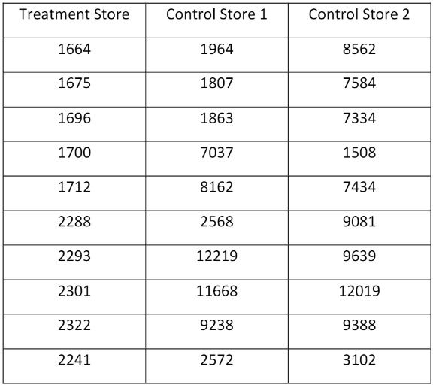

Table 1: Treatment and Control Stores Pairs

## Step 4: Analysis and Writeup

**What is your recommendation - Should the company roll out the updated menu to all stores?**

The company should update its menu at all the stores as the profit margin has increased by more than 18%.

**2. What is the lift from the new menu for West and Central regions (include statistical significance)?**

The lift for the West region is ~ **37.9** % while the lift for the Central region is ~**43.5**%. Overall both the regions have a statistical significance of **99.5**% and **99.6**% respectively.

**3. What is the lift from the new menu overall?**

The lift for the new menu overall is 40.7 % with a statistical significance of 100%.

**West Region**

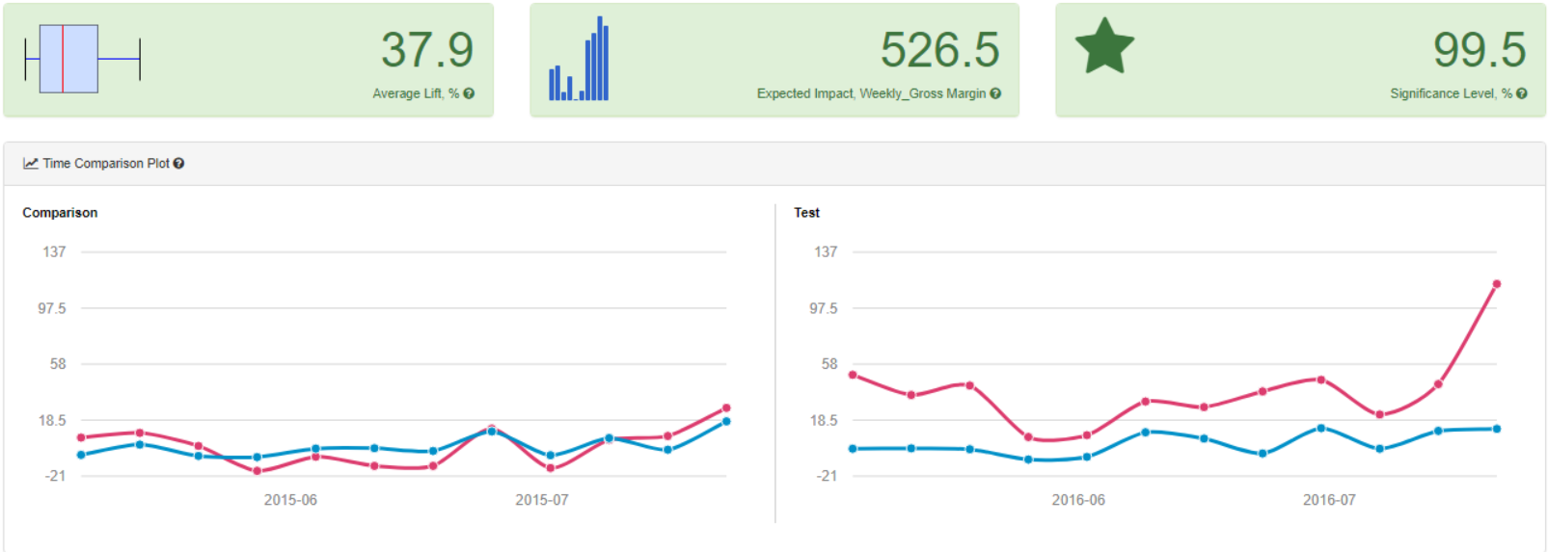

**Central Region**

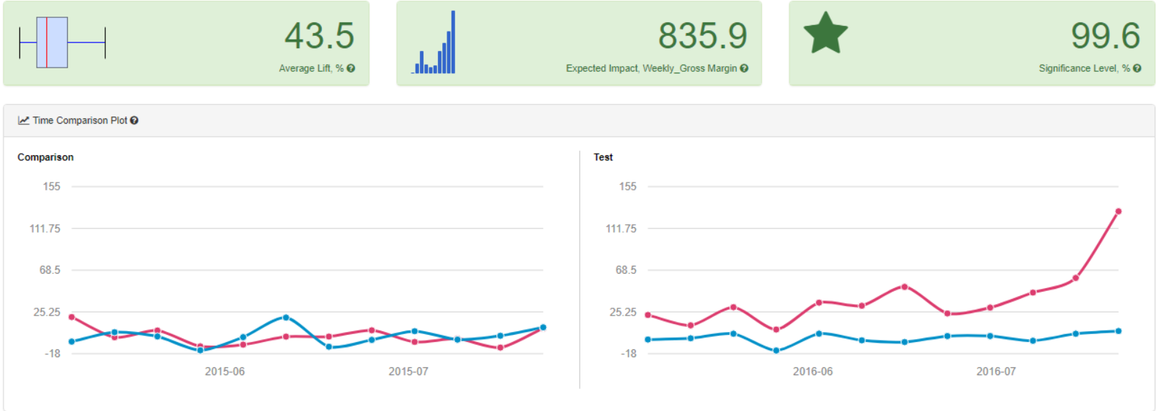

**Overall**

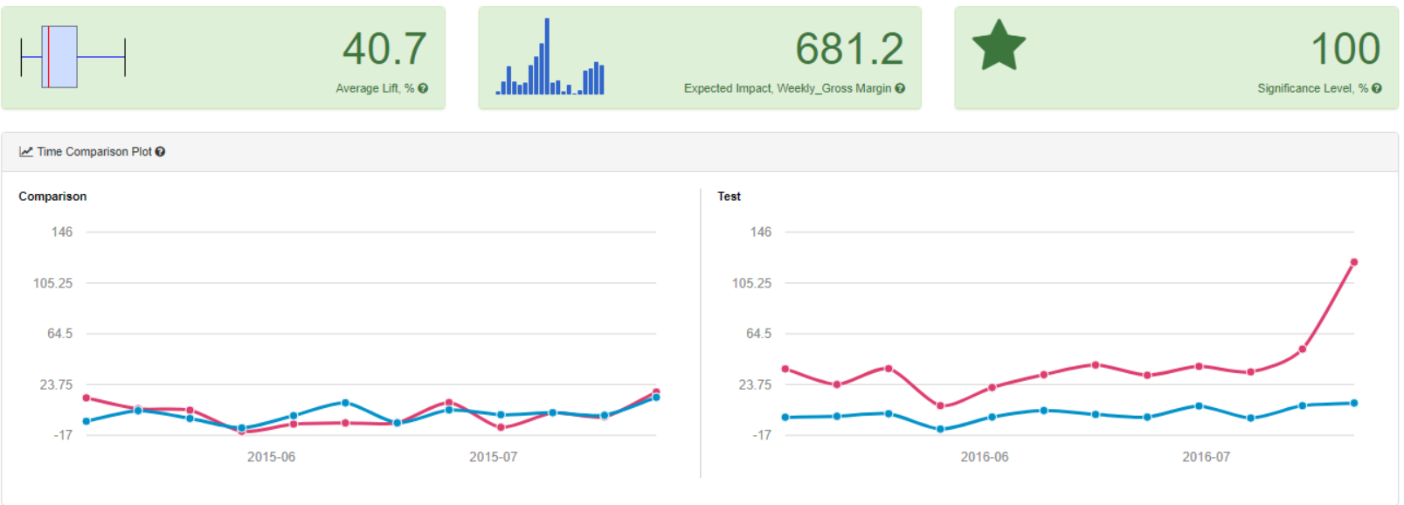

## **Alteryx Workflows**

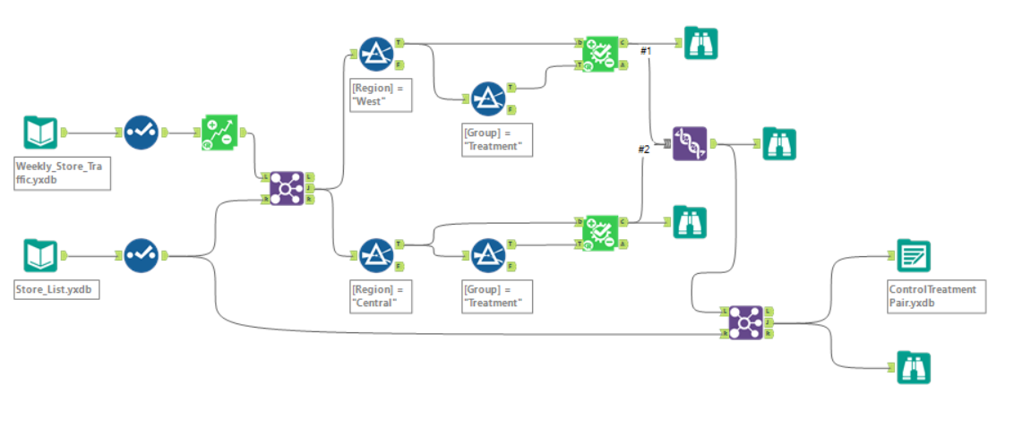

Figure 3: Treatment-Control pairing

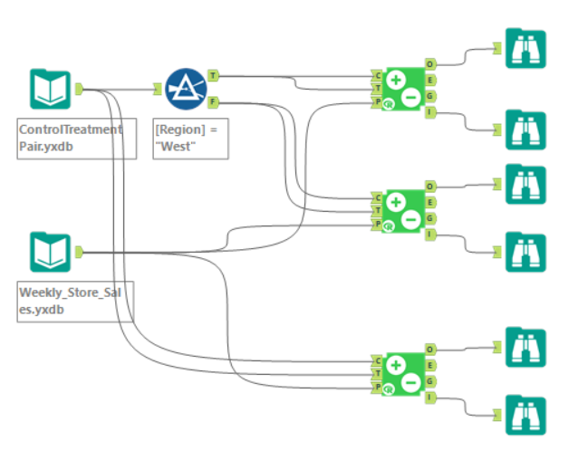

Figure 4: AB Testing